**HOME QUARANTINE USING FACE RECOGNITION**

**Aim:**

The home security system has become vital for every house. Previously, most doors can be open by using traditional ways, such as keys, security cards, password or pattern. However, incidents such as a key loss has led to much worrying cases such as robbery and identity fraud. This has become a significant issue. To overcome this problem, face recognition using deep learning technique was introduced and Internet of Thing (IoT) also been used to perform efficient door access control system. Raspberry Pi is a programmable small computer board and used as the main controller for face recognition, youth system and locking system. The camera is used to capture images of the person in front of the door. IoT system enables the user to control the door access.

**Hardware & Software Requirements:**

Web Camera

Raspbian OS

Python

RPi.GPIO Python Library

OpenCV (Open Source Computer Vision)

Numpy

Remote Desktop Protocol (RDP)

Servo Motor

**Project Flow**

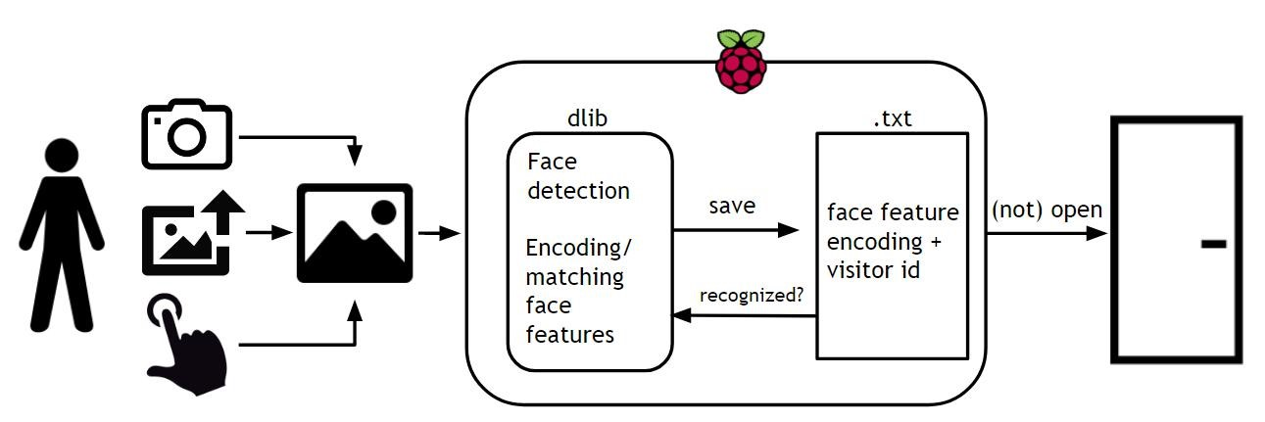

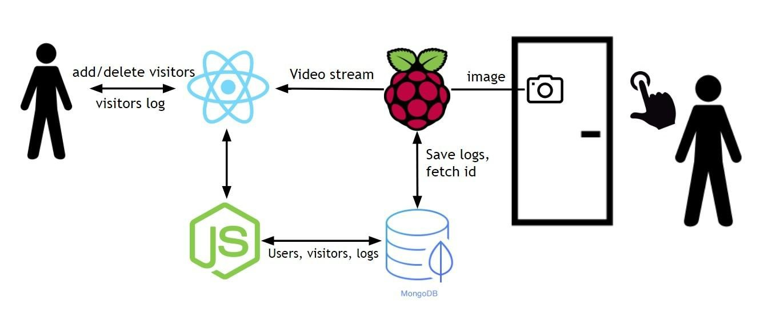

A Live video is captured from the webcam. The preprocessed frames are then converted to black and white, person is identified by finding the contours of the face and then, centroid of the face is calculated. Preprocessing of the frames include noise removal and conversion to grey scale. The frames are divided into virtual grids which help the robot to move to the object based on its centroid. Once the robot reaches the face and finds the face is stationary for few frames, it picks the object. The color of the picked face is analyzed and then the person is placed into its respective categorized container.

**Proposed Model**

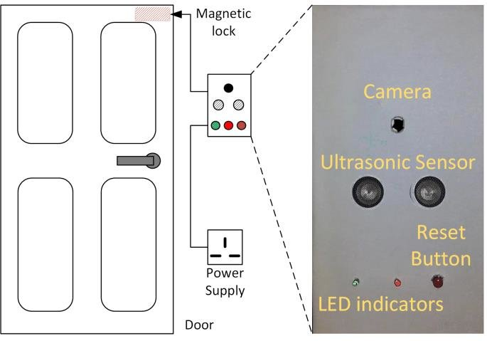

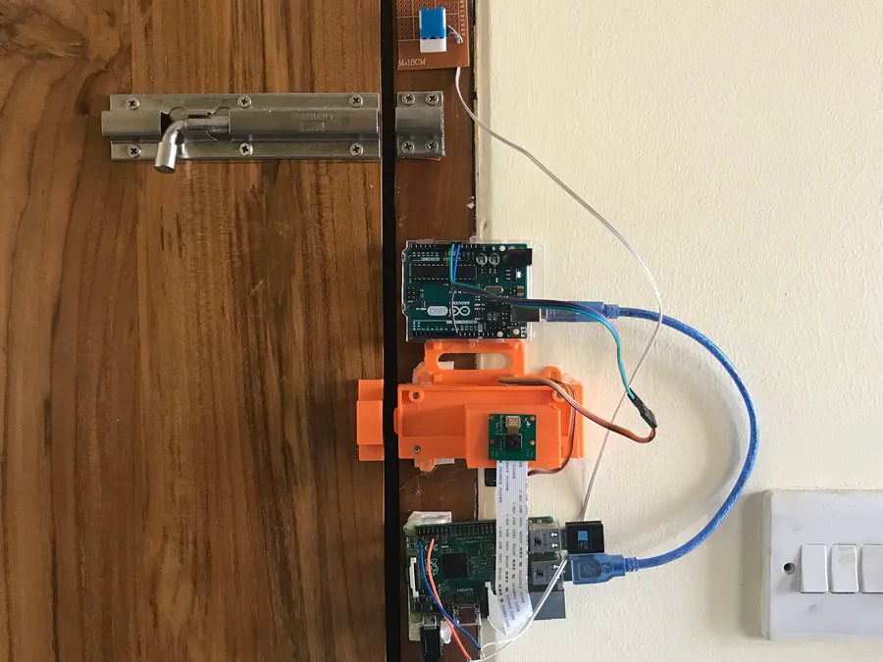

**Stakeholders:**

The first stake holders are those types of consumers who are aware of the pandemic and that restricts other people from entering their home without permission and It works by recognizing a face and allows only important members. And then comes the shopping malls, hotels, resorts & other offices who install these coz that is the place where more people are gathered and moreover those are the places which should be more aware of.

Last but not the least comes the front liners who always work hard to prevent the spreading of pandemic while come from the office and after leaving the office they should be sanitized in order to prevent them from spreading the diseases.

Finally comes the research areas where they perform experiment on various species and before they enter into another containment zone they should sanitize themselves to prevent causing infections to non-healthy inhabitant.